**Title – Cab Booking System**

|  |  |  |
| --- | --- | --- |
| **ENTITY** | **ATTRIBUTE** | **METHODS** |
| Cab | cabNo(int)  cabModel(String)  transmission(String)  capacity(int) | showCabDetails()  choose()  search()  showFare() |

|  |  |  |
| --- | --- | --- |
| **ENTITY** | **ATTRIBUTE** | **METHODS** |
| Passenger | cid(int)  idproof(String)  cname(String)  phoneNo(long) | add()  show()  edit()  request()  cancel()  book()  search()  checkFare() |

|  |  |  |
| --- | --- | --- |
| **ENTITY** | **ATTRIBUTE** | **METHODS** |
| Driver | name(String)  idproof(String)  phoneNo(long)  email(String)  drivingLicense(boolean) | acceptRide()  cancelRide()  showDriverDetails() |

|  |  |  |
| --- | --- | --- |
| **ENTITY** | **ATTRIBUTE** | **METHODS** |
| Trip | sourceString)  destination(String)  tripDuration(double)  distance(double)  tripFare(double) | beginTrip()  endTrip()  showFinalFare()  cancelTrip()  sendMessage() |

|  |  |  |
| --- | --- | --- |
| **ENTITY** | **ATTRIBUTE** | **METHODS** |
| Bill | billNo(int)  totalFare(double)  name(String) | makeBill()  showFinalFare()  sendMessage() |

|  |  |  |
| --- | --- | --- |
| **ENTITY** | **ATTRIBUTE** | **METHODS** |
| Payment | paymentId(int)  paymentMode(String) | paidSuccessfully()  paidUnsuccessfully()  showPaymentOption()  payByCash()  payByOnline() |

|  |  |  |
| --- | --- | --- |
| **ENTITY** | **ATTRIBUTE** | **METHODS** |
| Feedback | rating(int)  comments(String) | giveFeedback()  showFeedback() |

**CLASS DIAGRAM**

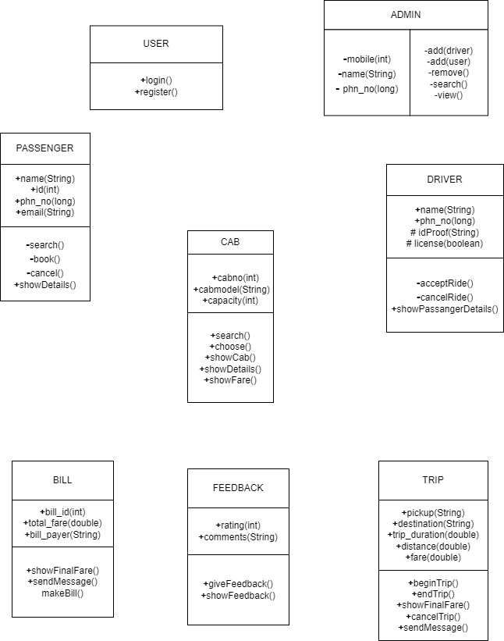

**TEST CASES**

1. Check is the location is enabled on the mobile/tab

2. Check that there is an option to search location.

3. Check the selection of all the available types of vehicle classes.

4. Check after booking a ride by selecting pickup, destination, time, and vehicle class. The app should start looking for a cab and should show the estimated time to find a cab.

5. Check On a confirmed booking, the app should show the cab and driver details.

6. Check the map to show the driver’s location and estimated time to arrive.

7. Check there is an option to call/message the driver.

8. Check that at allow one time only one booking is allowed

9. Check the cancellation option is available once the booking is confirmed.

10. Check on cancellation the current booking is aborted and the cancellation charge is deducted if applicable.

**USE CASE DIAGRAM**

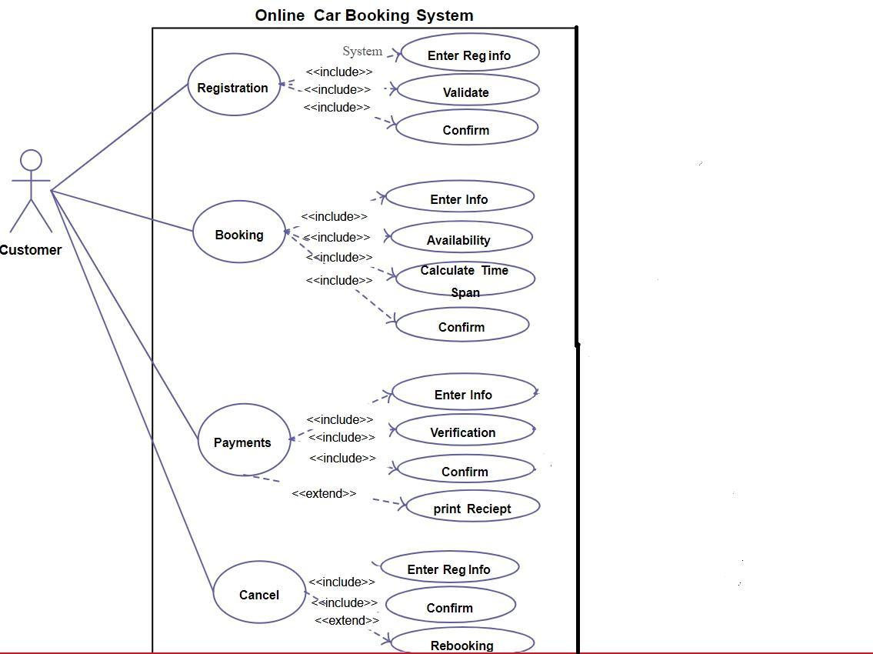

**DATABASE DESIGN**

create database car_booking_system;

use car_booking_system;

**CAB TABLE**

create table cab(

cabNo int,

cabModel int,

transmission varchar(20),

capacity int);

**PASSENGER TABLE**

create table passenger(

cid int,

idproof varchar(20),

cname varchar(25),

phone int);

**DRIVER TABLE**

create table driver(

name varchar(20),

idproof varchar(25),

phone int,

email varchar(25),

drivingLicense varchar(25));

**TRIP TABLE**

create table trip(

source varchar(20),

destination varchar(20),

tripduration double,

distance double,

tripFare double);

**BILL TABLE**

create table bill(

billNo int,

totalFare double,

cname varchar(20));

**PAYMENT TABLE**

create table payment(

paymentId long,

paymentMode varchar(15));

**FEEDBACK TABLE**

create table feedback(

rating int,

comments varchar(100));